**Balwinder Singh Hayer**

**Computer Communications**

**CPSC 471-04**

**LAB – 02-A**

**Due – FRI 08 2019**

1. The Basic HTTP GET/response interaction

1. Is your browser running HTTP version 1.0 or 1.1? What version of HTTP is the server running?

Ans: Below is the screenshot. My browser is running HTTP version 1.1 as we can see in the first screenshot. However, server is also running on HTTP version 1.1 which is showed in the 2nd screenshot as marked blue to the bottom.

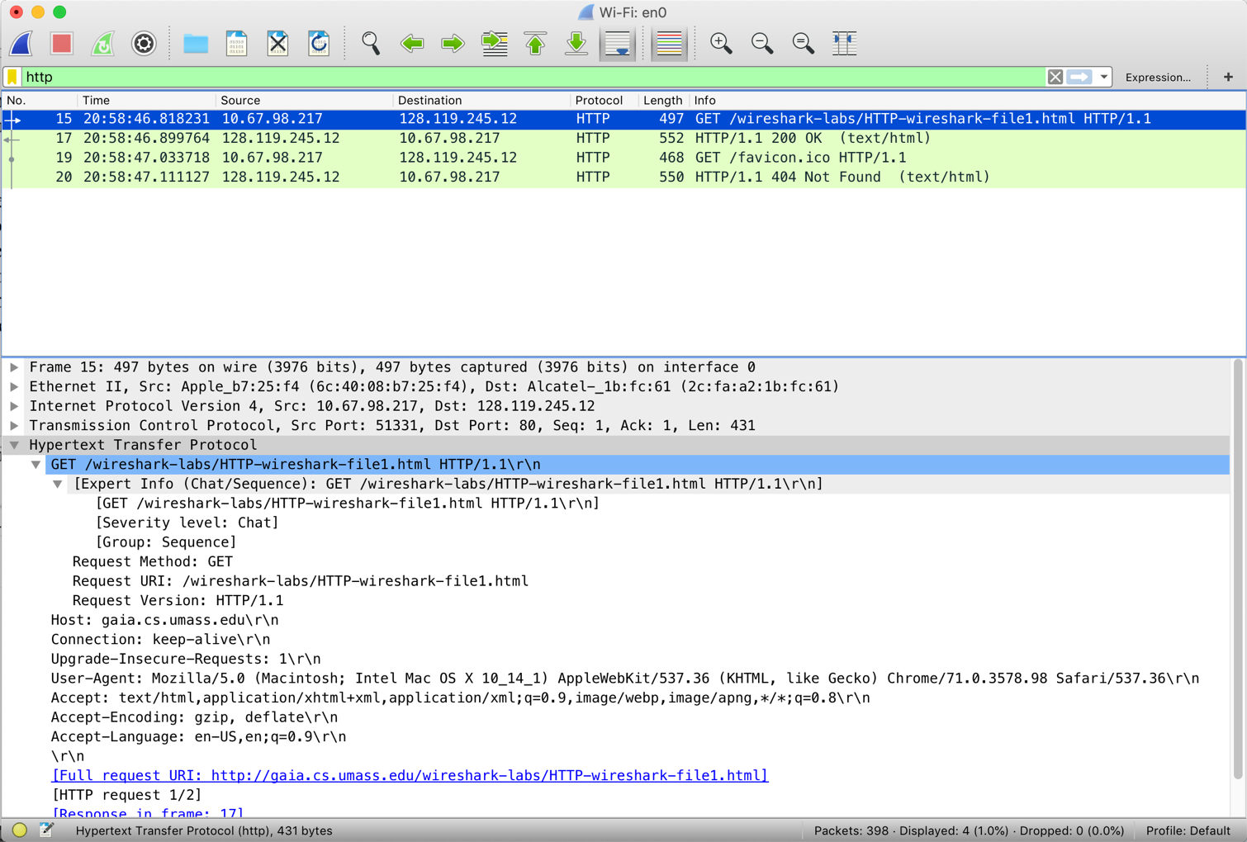

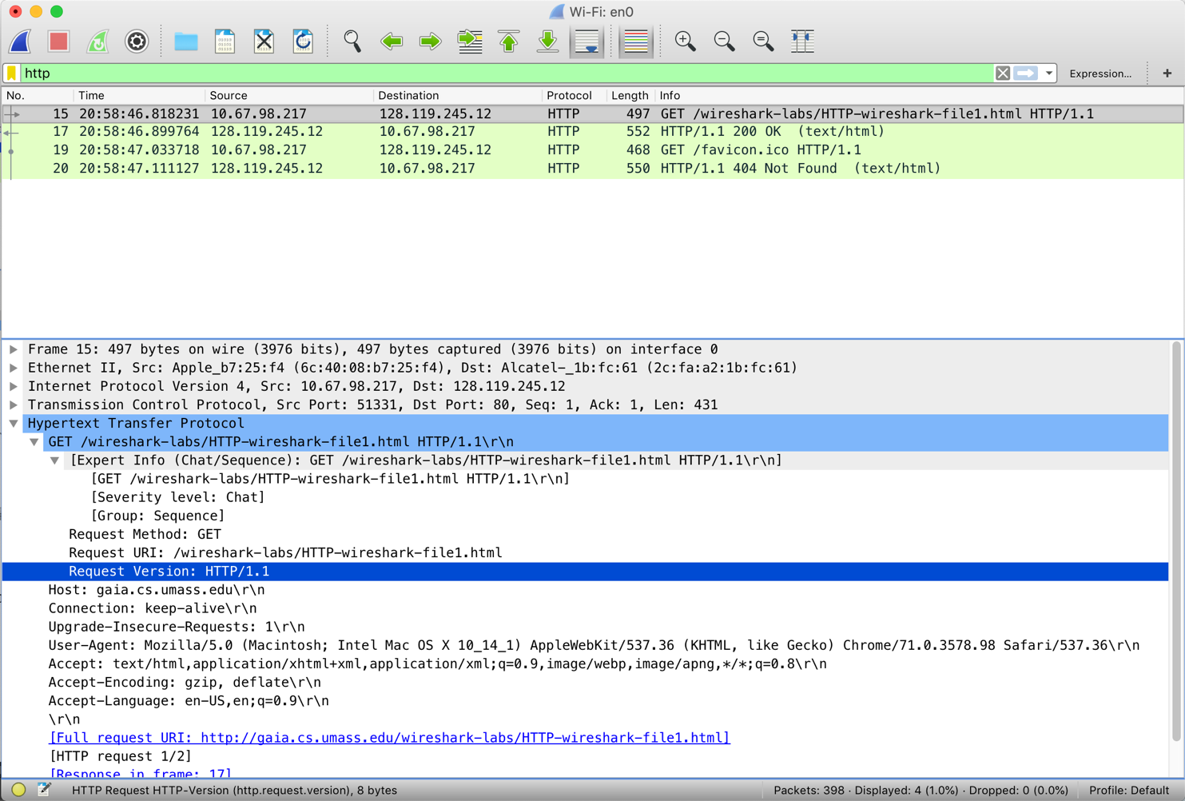

1. What languages (if any) does your browser indicate that it can accept to the server?

Ans: Browser accepts en-US language (English). (Below is the screenshot which shows the accepting language of browser to the server which is shaded as blue.)

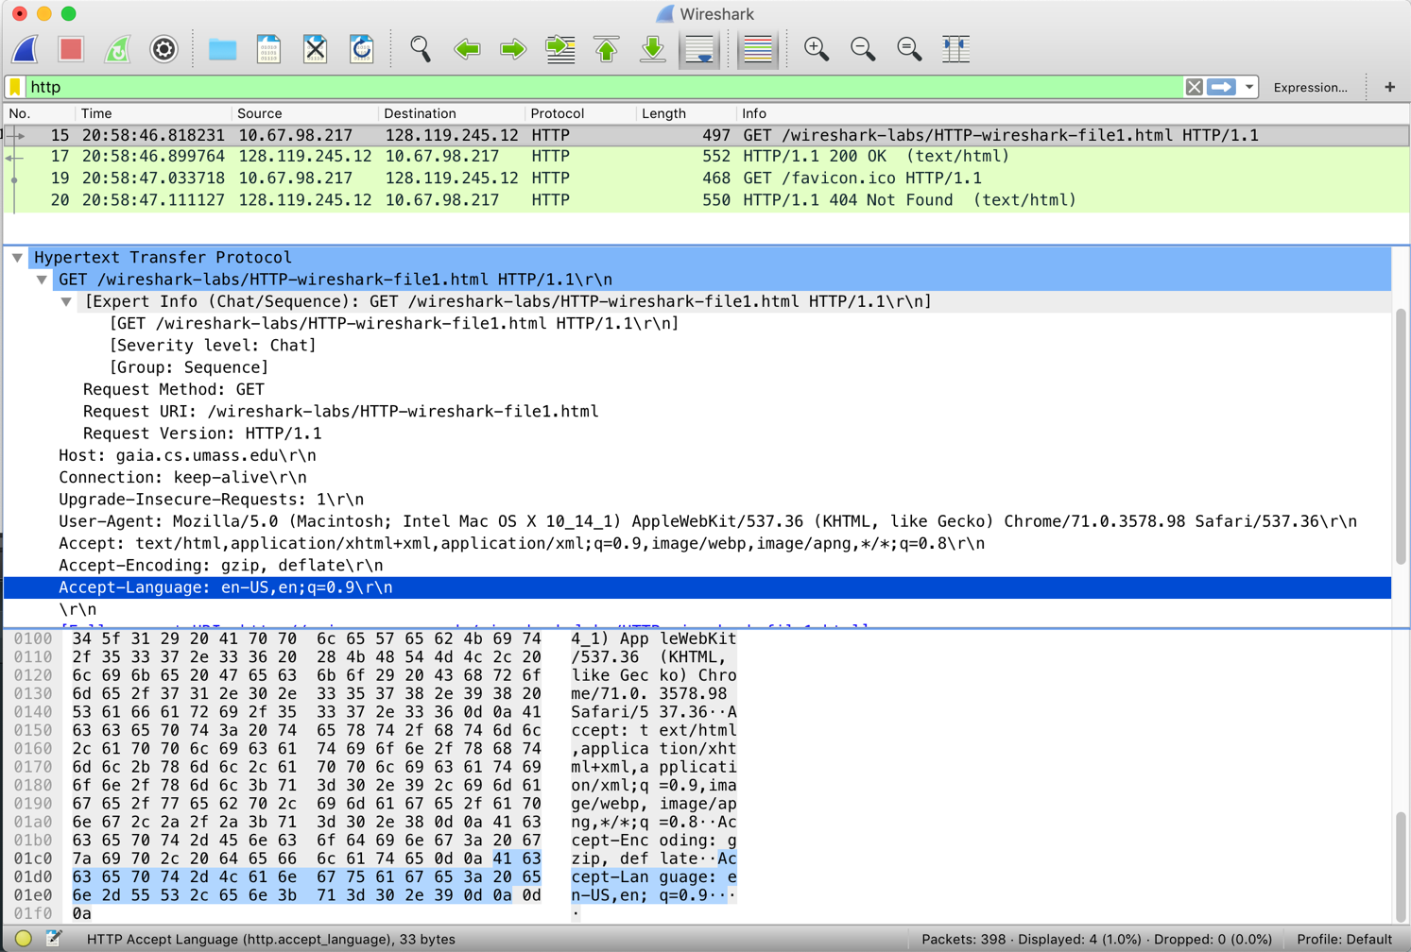

1. What is the IP address of your computer? Of the gaia.cs.umass.edu server?

Ans. IP address of my computer is Src: 10.67.98.217. (source)

IP address of server is Dst: 128.119.245.12 (gaia.cs.umass.edu) [destination]

Below is the screenshot showing both IP address of Source and Destination.

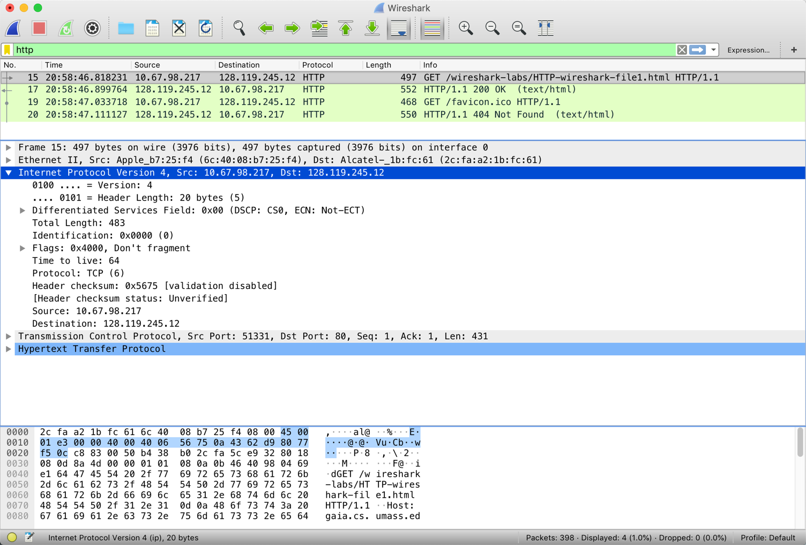

1. What is the status code returned from the server to your browser?

Ans: Status code returned from the server to my browser is 200 OK. It simply means that document is ok.

HTTP/1.1 200 OK (text.html)

Below is the snapshot of status code and its last modified date and time.

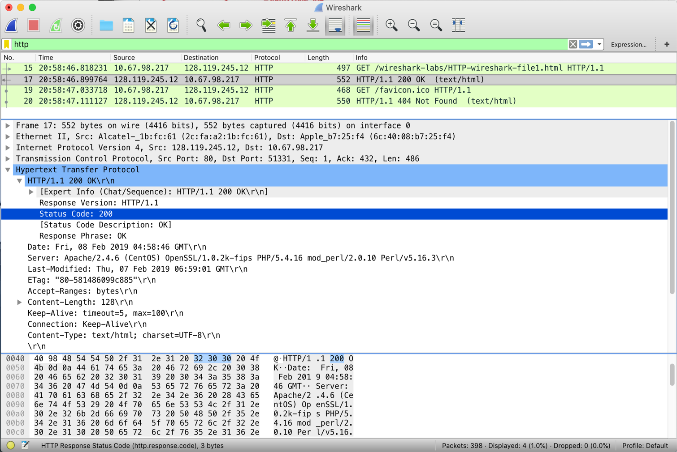

1. When was the HTML file that you are retrieving last modified at the server?

Ans:

Last-Modified: Thu, 07 Feb 2019 06:59:01 GMT\r\n

(Below is the screenshot of Last-Modification at server)

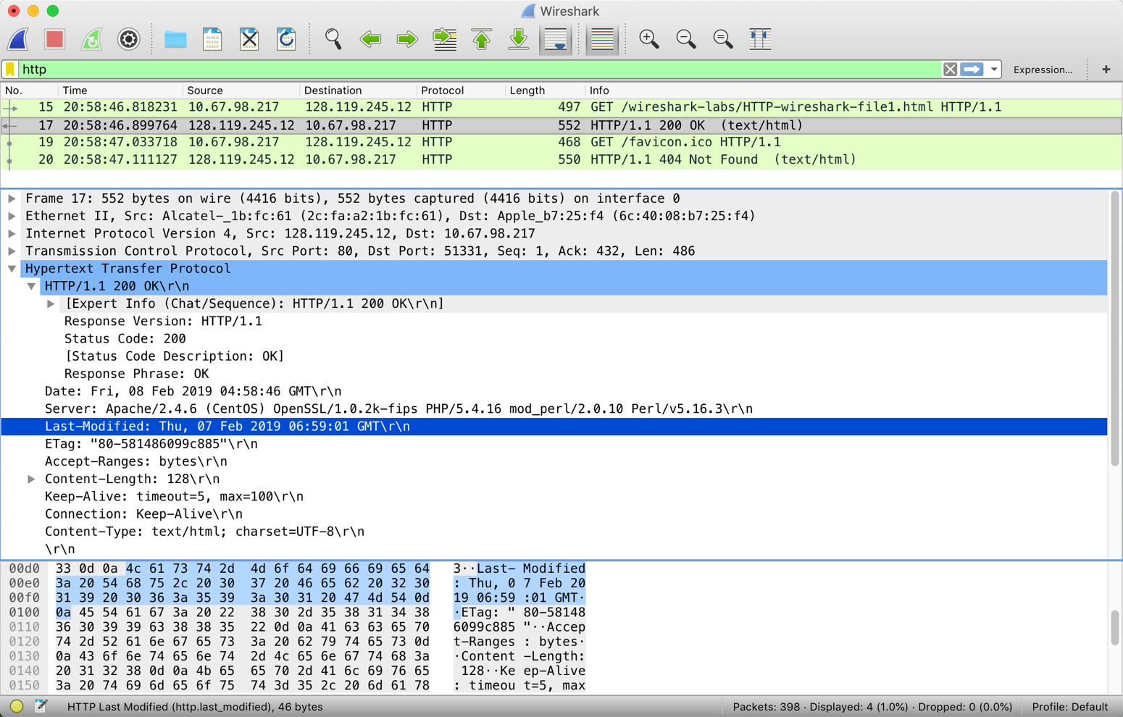

1. How many bytes of content are being returned to your browser?

Ans: Content-Length: 128\r\n

128 Bytes is being returned to the browser.

{below is the snapshot of content-length}

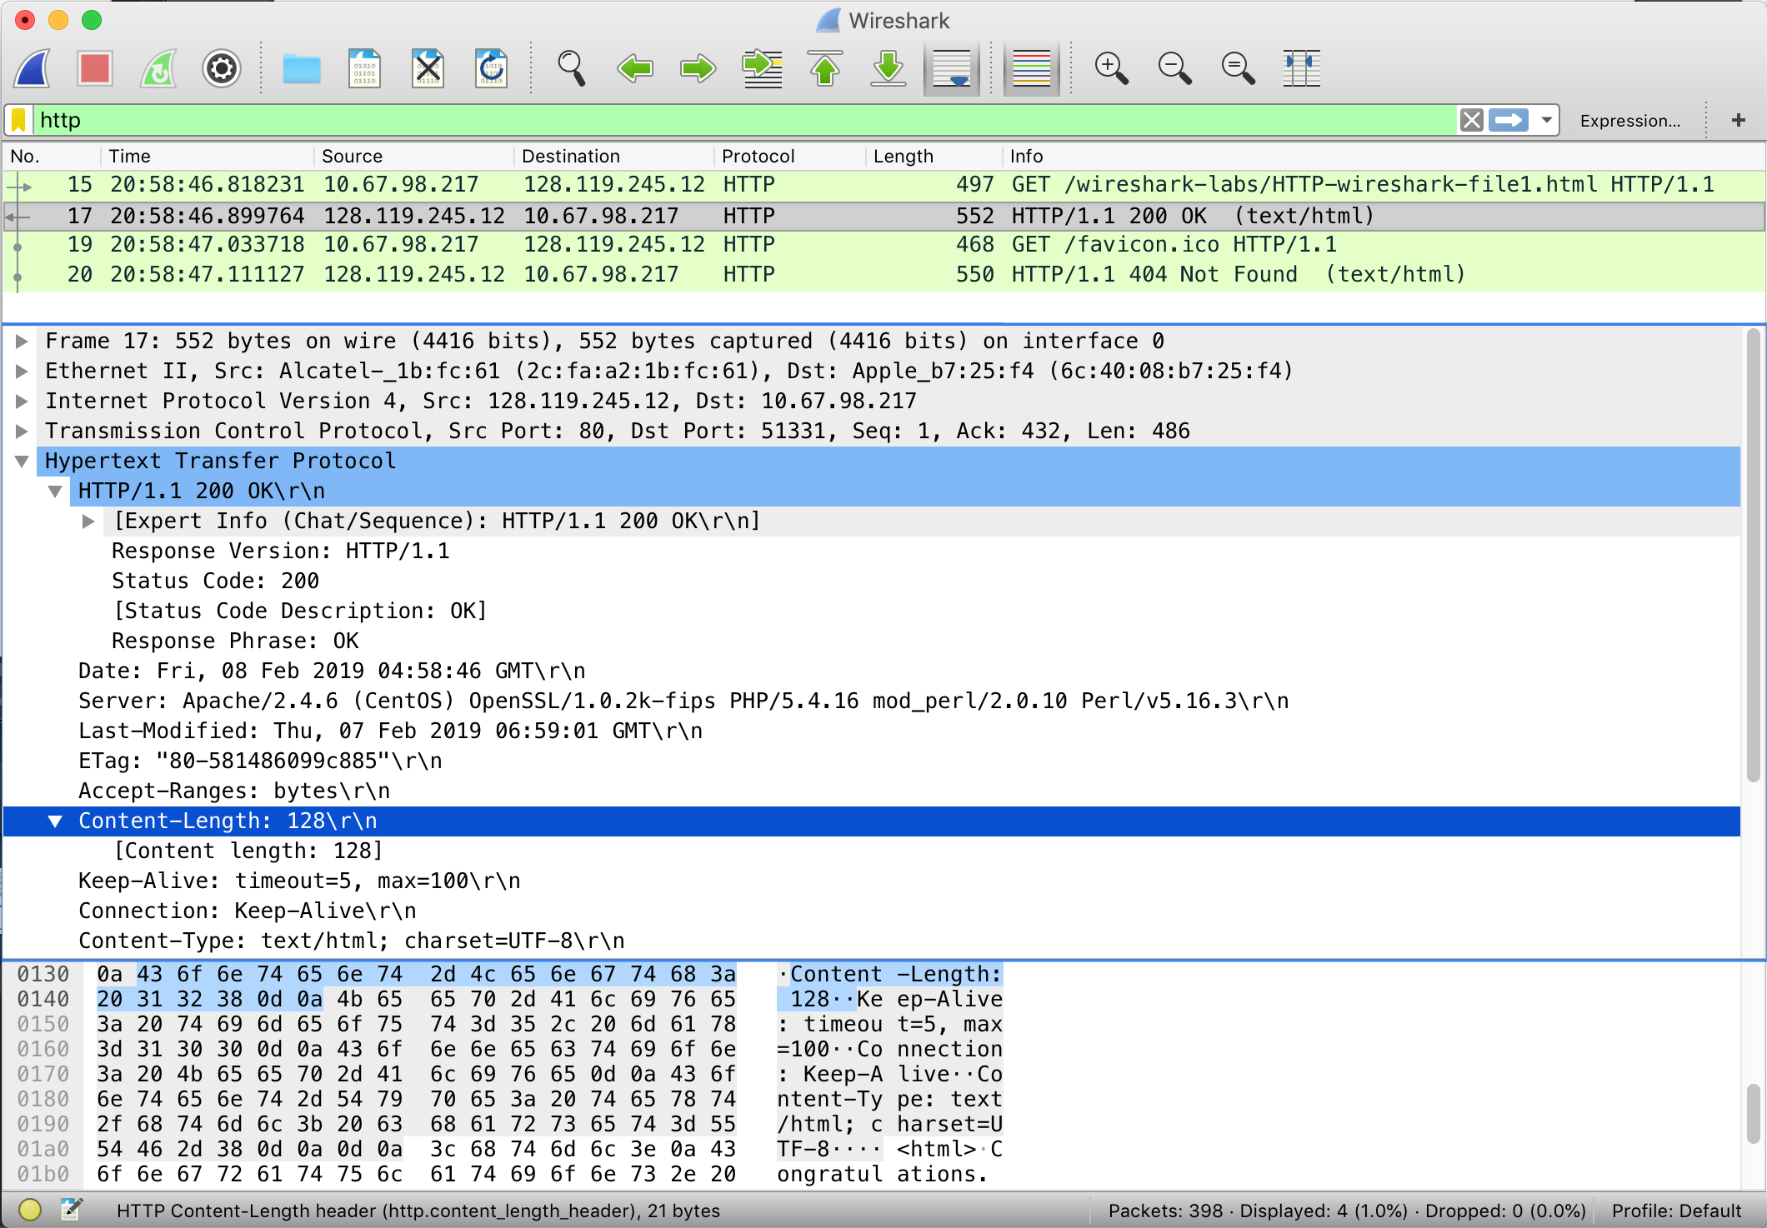

1. By inspecting the raw data in the packet content window, do you see any headers within the data that are not displayed in the packet-listing window? If so, name one.

Ans:

After inspecting the raw data in the packet content window, I do not see any headers within the data that are not displayed in the packet-listing window.

2. The HTTP CONDITIONAL GET/response interaction

**Answer the following questions:**

* 1. Inspect the contents of the first HTTP GET request from your browser to the

server. Do you see an “IF-MODIFIED-SINCE” line in the HTTP GET?

Ans: After inspecting the contents of first HTTP GET, there is no “IF-MODIFIED-SINCE” line in the HTTP GET. It is not found because web page saves the cached locally on the computer system, which request the server, so this would only show up if the web page is visited before.

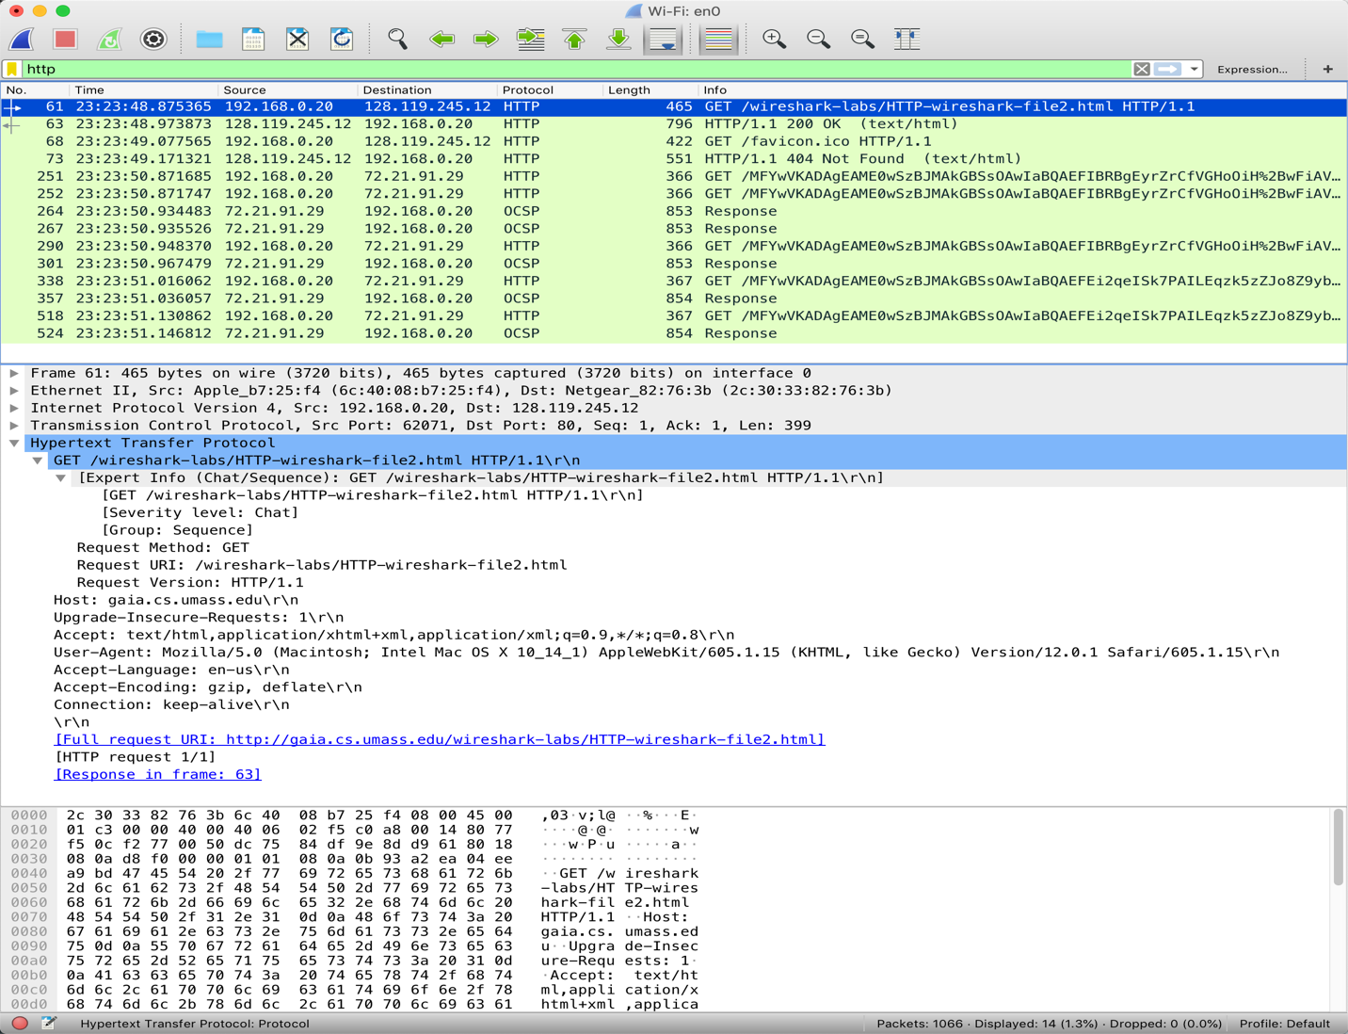

* 1. Inspect the contents of the server response. Did the server explicitly return the

contents of the file? How can you tell?

Ans: Yes, server explicitly return the contents of the file in the form of 200 OK message which was sent using Content-Length: 371\r\n (bytes). However, we can see the contents in the Line-based text data field.

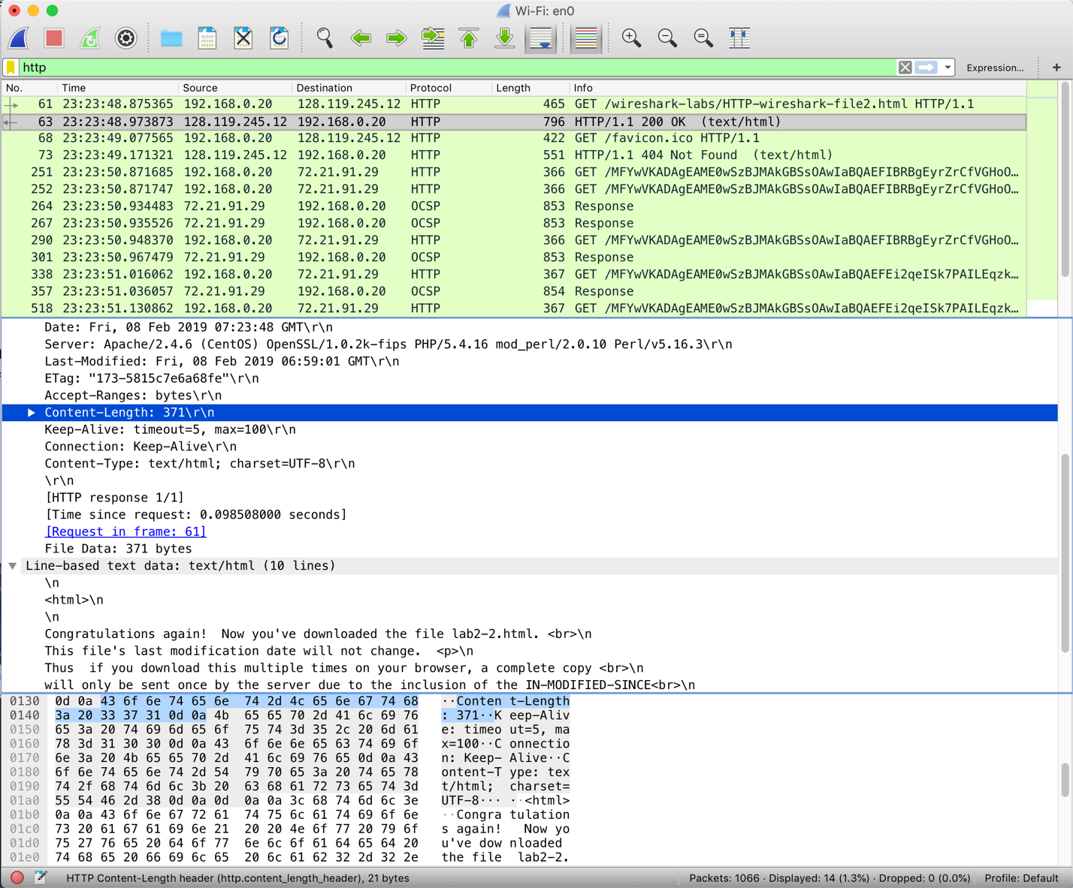

* 1. Now inspect the contents of the second HTTP GET request from your browser to

the server. Do you see an “IF-MODIFIED-SINCE:” line in the HTTP GET? If

so, what information follows the “IF-MODIFIED-SINCE:” header?

Ans: Yes, the information follows as:

Last-Modified: Fri, 08 Feb 2019 06:59:01 GMT\r\n

It is showing the date of the previous modification with the file from the last GET request.

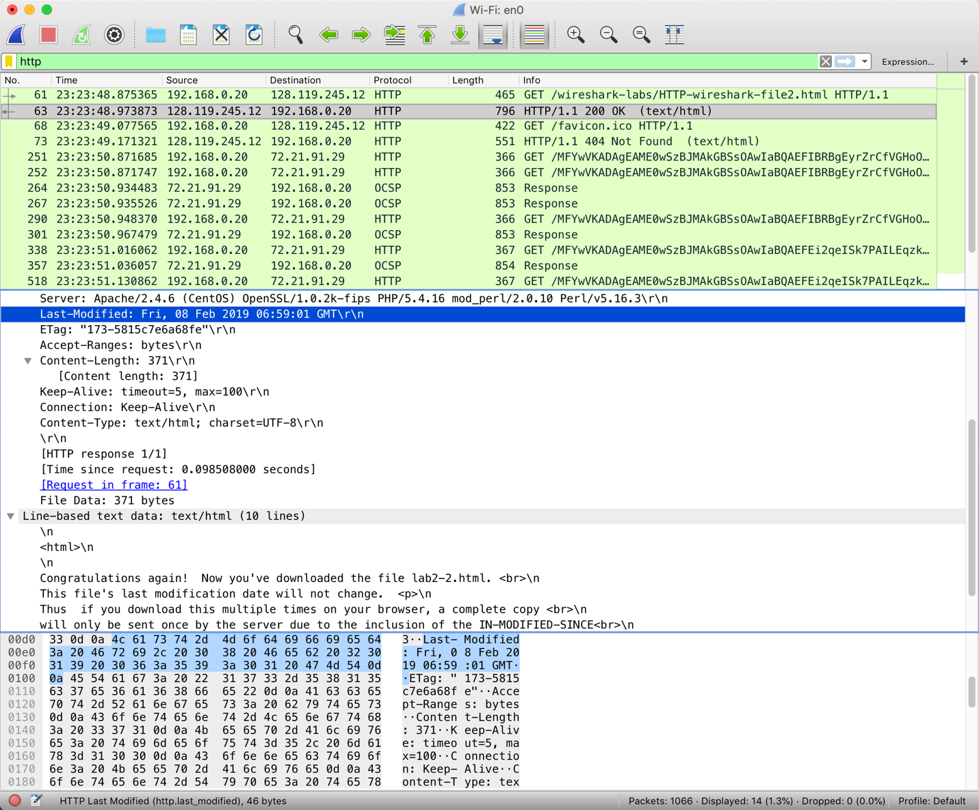

* 1. What is the HTTP status code and phrase returned from the server in response to this second HTTP GET? Did the server explicitly return the contents of the file?

Explain.

Ans: The status code and phrase returned from the server is 200 Not Modified. The server did not return the contents of the file since the browser loaded it from its cache.



**3. Retrieving Long Documents**

Answer the following questions:

1. How many HTTP GET request messages did your browser send? Which packet number in the trace contains the GET message for the Bill or Rights?

Ans: There was only 1 HTTP GET request message sent by my browser as shown in the screenshot. There was only one packet number 92 used.



1. Which packet number in the trace contains the status code and phrase associated with the response to the HTTP GET request?

Ans: Packet# 100 contained the response to the HTTP GET request.



1. What is the status code and phrase in the response?

Ans. The status code from this packet was 200, and the phrase was an OK.

1. How many data-containing TCP segments were needed to carry the single HTTP response and the text of the Bill of Rights?

Ans: There were 4 data containing TCP segments were needed to carry the single HTTP response and the text of the Bill of Rights as shown in the screenshot below.

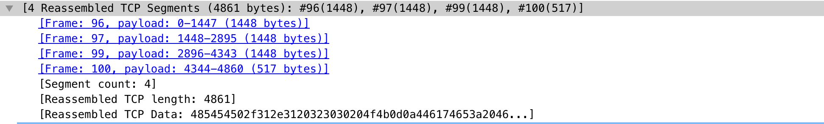

4. HTML Documents with Embedded Objects

Answer the following questions:

16. How many HTTP GET request messages did your browser send? To which Internet addresses were these GET requests sent?

Ans: There were 2 HTTP GET requests sent to following Internet addresses in the screenshot below.

128.119.245.12

192.168.0.20.

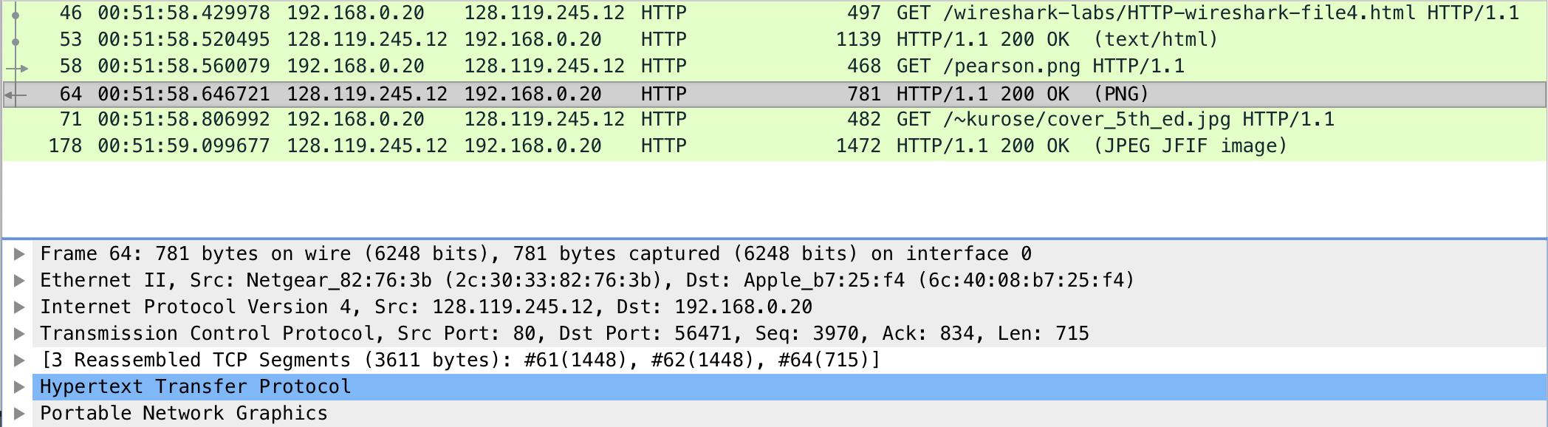

17. Can you tell whether your browser downloaded the two images serially, or whether they were downloaded from the two web sites in parallel? Explain.

Ans: The two images were downloaded serially. The first image was requested and retrieved with a status of 200 OK. Then the browser tried to download the second image and had a response of 200 OK again.

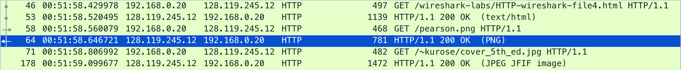

**5. HTTP Authentication**

Answer the following questions:

18. What is the server’s response (status code and phrase) in response to the initial HTTP GET message from your browser?

Ans: The server’s response to my HTTP GET message is a 401 Unauthorized and phrase is Unauthorized.

Status Code: 401

Response Phrase: Unauthorized

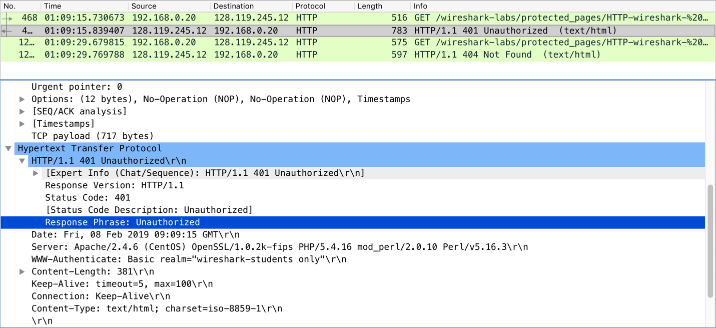

19. When your browser’s sends the HTTP GET message for the second time, what new field is included in the HTTP GET message?

Ans: New field is the Authorization field. This provides the user name and password. Then it returned with 404 Not Found message as shown below.

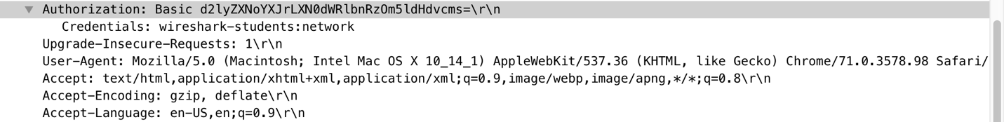



=====END====